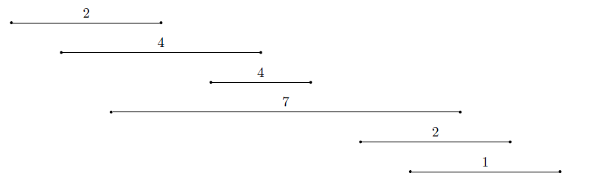interval selected are the ones circled



2.

for i = 1...n do

// we can do binary search here since it is sorted by finish time

binary search for $j$ in interval [$1…(i-1)$] with latest finish time $f_{j}$ such that $f_{j}≤s_{i}$

if such j is found then

p[i] = j

else

p[i] = 0

By doing binary search for j, the overall time complexity of this algorithm is $Ο(n\log{n)}$